CrowSoft Sprint 1 Report

Author: Michael McFadden

Date: 26/03/2019

CSOFT Sprint 1 goal - Setting up Infrastructure - Development VM to Host Application & DB - Jenkins VM & Analysis and research for tools

Infrastructure

* Set up a VM to Host Jenkins environment
* Install Jenkins on VM server
* Setup Development VM to host application
* Set up .NET on DEV VM, to run and test our applications on the dev server
* Install MySQL on the Application Server
* Setup ssh on the development server, so that we can access the server remotely
* Create an empty project using Dotnet Core, so all developers can add code to the Dotnet project

Research & Documentation

* Research GitHub Branches
* Explore reporting tools to report to product owner team efficiencies.
* Explore Git Integration for Jira to allow better tracking and explore available tools
* Investigate a better way to score effort on planning sessions

Stories Not completed and carried over into Sprint 2

* configure MySQL on the Application Server

Reporting Diagrams

Burndown chart

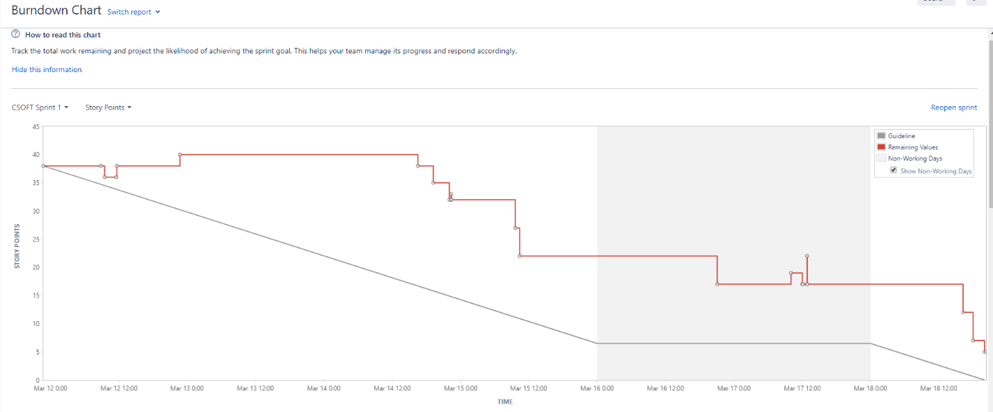

Status Report

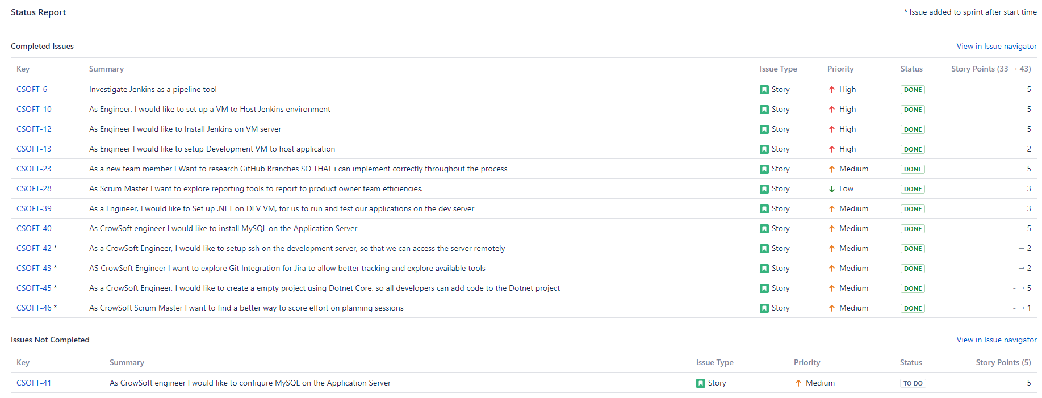

Cumulative Flow Diagram

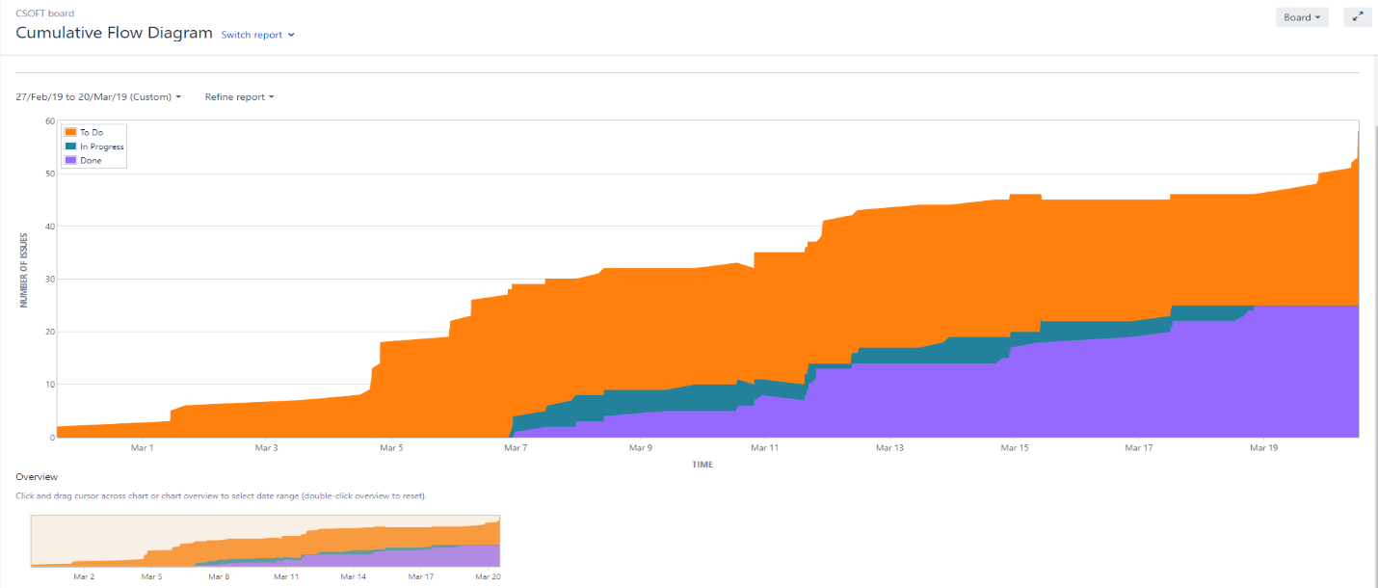

Velocity Chart

